**CS 200**

**Homework 2: Universal Gates & Flip Flops**

Brandon Horner

**February 06, 2013**

**Assignment**

Answer each of the following questions based on Chapter 3 of the Null textbook.

1. Which gates are called "universal" gates? Why? (2 pts.)

NAND and NOR gates are universal gates. They are inexpensive to manufacture and any Boolean function can be constructed using only them.

1. 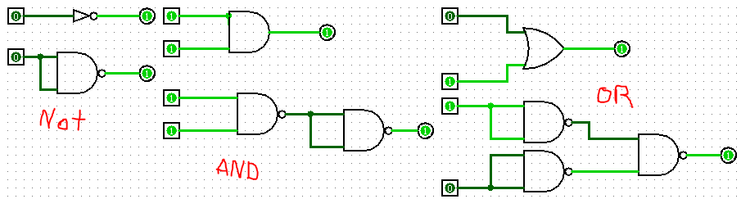Draw two sets of logic circuits for AND, OR, and NOT using each of the universal gates from question 1. In other words, draw an AND circuit using only the one kind of gate and then draw it again using only the other kind of gate. (3 pts.)
2. What's the difference between combinational logic and sequential logic? (2 pts)

Combinational logic circuits implement Boolean expressions very quickly; they only need input to work. Sequential circuits compute their output based on input and state, the state being changed based on a clock.

1. What ARE flip-flops? (2 pts.)

Flip-flops are circuits that have two stable states and can be used to store state.

1. Make a table showing all the state transitions for a J-K flip-flop. (1 pt.)

|  |  |  |  |
| --- | --- | --- | --- |
| J | K | Q(t+1) | Q |
| 0 | 0 | Q | keep state |
| 0 | 1 | 0 | reset state |
| 1 | 0 | 1 | set state |
| 1 | 1 | !Q | toggle state |